**VISVESVARAYA TECHNOLOGICAL UNIVERSITY**

**Belagavi-590018**

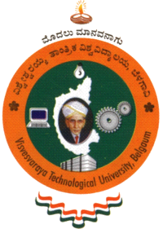

**A Report on National Service Scheme (NSS)**

**BNSK359**

Submitted by

|  |  |
| --- | --- |
| **RAKSHITA J** | **4SN23CS083** |

In partial fulfillment of the requirements for the Degree of

**BACHELOR OF ENGINEERING**

IN

**COMPUTER SCIENCE AND ENGINEERING**

|  |
| --- |
| Department NSS coordinator |
| **Prof. A Aishwarya**  Assistant Professor |



**Department of Computer Science and Engineering**

**SRINIVAS INSTITUTE OF TECHNOLOGY**

**MANGALURU-574143, KARNATAKA**

**2024-2025**

|  |  |  |  |  |  |  |  |  |  |  |  |  |  |  |  |  |  |  |  |  |  |  |  |  |  |  |  |  |  |  |  |  |  |  |  |  |  |  |  |  |  |  |  |  |  |  |  |  |  |  |  |  |  |  |  |  |  |  |  |  |  |  |  |  |  |  |  |  |  |  |  |  |  |  |  |  |  |  |  |  |  |  |  |  |  |  |  |  |  |  |  |  |  |  |  |  |  |  |  |  |  |  |  |  |  |  |  |  |  |  |  |  |  |  |  |  |  |  |  |  |  |  |  |  |  |  |
| --- | --- | --- | --- | --- | --- | --- | --- | --- | --- | --- | --- | --- | --- | --- | --- | --- | --- | --- | --- | --- | --- | --- | --- | --- | --- | --- | --- | --- | --- | --- | --- | --- | --- | --- | --- | --- | --- | --- | --- | --- | --- | --- | --- | --- | --- | --- | --- | --- | --- | --- | --- | --- | --- | --- | --- | --- | --- | --- | --- | --- | --- | --- | --- | --- | --- | --- | --- | --- | --- | --- | --- | --- | --- | --- | --- | --- | --- | --- | --- | --- | --- | --- | --- | --- | --- | --- | --- | --- | --- | --- | --- | --- | --- | --- | --- | --- | --- | --- | --- | --- | --- | --- | --- | --- | --- | --- | --- | --- | --- | --- | --- | --- | --- | --- | --- | --- | --- | --- | --- | --- | --- | --- | --- | --- | --- | --- |
| |  |  |  |  |  |  |  |  |  | | --- | --- | --- | --- | --- | --- | --- | --- | --- | | **SRINIVAS INSTITUTE OF TECHNOLOGY**  **MANGALURU - 574 143, KARNATAKA** | | | | | | | | | |  | | | | | | | | | | **DEPARTMENT OF COMPUTER SCIENCE AND ENGINEERING** | | | | | | | | | |  | | |  | | |  | | | | **CERTIFICATE** | | | | | | | | | | It is to certify that the report on National Service Schemecarried out at  **Srinivas Institute of Technology Mangalore**  is a Bonafide work carried out by | | | | | | | | | |  | **RAKSHITA J** | | | | **4SN23CS083** | | |  | |  |  | | | |  | | |  | | in partial fulfilment for the award of **Bachelor of Engineering** in Computer Science and Engineering of the **Visvesvaraya Technological University, Belagavi** during the year 2024-25. It is certified that all corrections/suggestions indicated for Internal Assessment have been incorporated in the report deposited in the Departmental library. The NSS report has been approved as it satisfies the academic requirements in respect of National Service Scheme prescribed for the Bachelor of Engineering Degree. | | | | | | | | | |  | | | | | | | | | | **---------------------------------**  **Prof. A Aishwariya** | | **---------------------------**  **Dr. Suresha D** | | | | | **----------------------------------**  **Dr. Shrinivasa Mayya D** | | | **NSS Coordinator** | | **HOD** | | | | | **Principal** | | |  | | | |  | | |  | | |  | | | |  | | |  | | |

**CONTENTS**

|  |  |  |
| --- | --- | --- |
| **Chapter No.** | **Headings** | **Page No.** |
| 1 | Introduction | 2-3 |
| 2 | Methodology | 4-6 |
| 3 | Inference and Observation | 7 |
| 4 | Conclusion | 8-9 |
| 5 | Geo Tagged Photos | 10 |

**ACKNOWLEDGEMENT**

The satisfaction that accompanies the successful completion of any work would be incomplete without thanking the persons who made it perfect with their constant guidance and encouragement.

I take this opportunity to express my sincere thanks and indebtedness to mentor, **Prof. A Aishwariya, Assistant Professor, Department of CS&E**, for her support and guidance. Her vision and suggestions throughout the NSS period have been fundamental in the completion of the NSS work.

I would like to extend my deep sense of acknowledgement to **NSS Co-Ordinator Prof. A Aishwarya Assistant Professor, Department of CS&E**, for her encouragement and timely advice provided to us during the NSS work.

I extend my warm gratitude to **Dr. Suresha D, Department of CS&E**, for his constant support and advice that helped us to complete this NSS work successfully.

I extremely grateful to our beloved **Principal, Dr. Shrinivasa Mayya D** for his encouragement to come up with new ideas and advice to express them in a systematic manner.

**Student Name: RAKSHITA**

**USN:4SN23CS083**

**Chapter 1**

**INTRODUCTION**

Women empowerment is a transformative and multidimensional process that enables women to take control of their lives, exercise their rights, and participate fully in society. It involves promoting gender equality, challenging patriarchal norms and stereotypes, and addressing the social, economic, cultural, and political barriers that prevent women from realizing their full potential. Empowering women is essential for achieving gender equality, promoting social justice, and driving sustainable development, as it can lead to improved health outcomes, increased education and economic opportunities, and enhanced political participation. Moreover, women's empowerment can have a positive impact on families, communities, and societies as a whole, contributing to reduced poverty, increased economic growth, and improved overall well-being.

**OBJECTIVES**

**Economic Objectives**

1. Economic Independence: Enable women to earn a living and support themselves and their families.

2. Increased Income: Improve women's income and access to financial resources.

3. Job Creation: Create job opportunities for women in various sectors.

**Social Objectives**

1. Social Equality: Promote social equality and challenge discriminatory practices.

2. Empowerment through Education: Educate women about their rights, health, and well-being.

3. Community Participation: Encourage women's participation in community decision-making processes.

**Political Objectives**

1. Leadership Development: Develop women's leadership skills and promote their participation in politics.

2. Policy Influence: Influence policy decisions that affect women's lives.

3. Women's Representation: Increase women's representation in elected bodies and decision-making positions.

**Psychological Objectives**

1. Confidence Building: Build women's confidence and self-esteem.

2. Emotional Empowerment: Empower women emotionally to make informed decisions.

3. Resilience: Enhance women's resilience to cope with challenges.

**Health Objectives**

1. Improved Health: Improve women's physical and mental health.

2. Access to Healthcare: Increase women's access to healthcare services.

3. Nutrition and Wellness: Promote women's nutrition and overall wellness.

* 1. **OVERVIEW**

Women's empowerment is a process that enables women to take control of their lives, make informed decisions, and participate fully in society. It involves economic, social, political, and psychological empowerment, leading to improved health, education, and economic opportunities. By challenging discriminatory practices and promoting equality, women's empowerment fosters a more just and equitable society.

**1.2.1 Strategies for Empowerment**

1. Education and Training: Providing access to education, vocational training, and skills development.

2. Economic Opportunities: Creating job opportunities, providing access to credit, and promoting entrepreneurship.

3. Policy and Legislative Reforms: Advocating for policies and laws that promote women's rights and empowerment.

**1.2.2 Key Components**

1.Autonomy and Decision-Making: Ability to make informed decisions about one's life, health, and well-being.

2. Community Engagement and Participation: Participation in community activities, social movements, and advocacy efforts.

**Chapter 2**

**METHODOLOGY**

**2.1 PREPARATION:**

Preparation for women's empowerment involves creating awareness, building capacity, and providing access to education, healthcare, and economic resources. It also requires policy support, legislative reforms, and community engagement to create a conducive environment for women's empowerment.

**2.2 IDENTIFYING THE PROJECT AREA AND SCOPE:**

Identifying the project area and scope of women's empowerment involves selecting a specific geographic location, such as rural or urban areas, and defining the target population, such as marginalized or underprivileged women. The scope includes assessing the community's needs, resources, and existing initiatives to determine the most effective interventions for empowering women.

**2.3 COMMUNITY INVOLVEMENT:**

**Community involvement is crucial for women's empowerment. Here are some ways to involve the community:**

1. Community Meetings: Organize meetings to discuss women's empowerment issues and involve community members in decision-making.

2. Volunteer Engagement: Encourage community members to volunteer their time and skills to support women's empowerment initiatives.

3. Community-Based Projects: Implement projects that address specific community needs, such as education, healthcare, and economic empowerment.

4. Partnerships with Local Organizations: Collaborate with local organizations, such as NGOs, community groups, and places of worship.

5. Capacity Building: Provide training and capacity-building programs for community members to develop skills and knowledge on women's empowerment.

6. Community Outreach: Conduct outreach activities, such as door-to-door visits, to raise awareness and involve community members in women's empowerment initiatives.

7. Involving Men and Boys: Engage men and boys in women's empowerment initiatives to promote gender equality and challenge patriarchal attitudes.

8. Establishing Community Groups: Establish community groups, such as women's self-help groups, to provide a platform for women to come together and support each other.

**2.4 Women's empowerment can be achieved through a variety of methodologies, including:**

* **Education: -** Providing women with education, awareness, and literacy can help raise their status in society.
* **Life skills: -** Teaching women life skills can help them make rational decisions and take responsibility for themselves and their communities.
* **Equity approach**: - This approach promotes women's equal rights and status so that they can be equal to men.
* **Empowerment approach**: - This approach encourages women to be self-reliant and to influence change in their own lives.
* **Building agency**: - This approach focuses on building women's consciousness, confidence, self-esteem, and aspirations.
* **Considering different types of power**: - Some say that efforts to empower women should consider different types of power, such as power over, power with, power to, and power within.

**2.5 Government schemes**

**Economic Empowerment Schemes**

1. Pradhan Mantri Mudra Yojana (PMMY): Provides loans to women entrepreneurs for starting or expanding their businesses.

2. Stand-Up India Scheme: Provides loans to women entrepreneurs from SC/ST and minority communities.

3. Mahila E-Haat: An online platform for women entrepreneurs to sell their products.

**Education and Skill Development Schemes**

2. National Scheme of Incentives to Girls for Secondary Education (NSIGSE): Provides financial incentives to girls from economically weaker sections to pursue secondary education.

3. Pradhan Mantri Kaushal Vikas Yojana (PMKVY): Provides vocational training to women, enabling them to acquire skills for employment.

**Health and Wellness Schemes**

1. Pradhan Mantri Surakshit Matritva Abhiyan (PMSMA): Provides free antenatal care to pregnant women on the 9th of every month.

2. Janani Suraksha Yojana (JSY): Provides financial assistance to pregnant women for institutional delivery.

**Safety and Protection Schemes**

1. One-Stop Centre (OSC) Scheme: Provides integrated support services to women affected by violence.

2. National Commission for Women (NCW): A statutory body that works to promote and protect women's rights.

3. Women's Helpline (181): A 24/7 helpline for women in distress.

**Chapter 3**

**INFERENCE AND OBSERVATION**

Inferences and observations of women's empowerment reveal a transformative impact on individuals and communities. Increased confidence, self-esteem, and decision-making skills are evident, alongside improved economic independence and participation in social activities. Observations also show a growing number of women in leadership positions, women-owned businesses, and improved access to education and healthcare. Furthermore, a decline in gender-based violence and harassment, as well as increased community support, demonstrate a shift towards a more equitable society.

**3.1 Outcomes:**

The outcomes of women's empowerment are far-reaching and transformative. Empowered women experience improved economic status, enhanced decision-making, and better health and well-being. They have increased access to education and skills development, leading to greater participation in leadership positions and community development. Ultimately, women's empowerment reduces poverty and inequality, improves social status, and contributes to stronger, more resilient communities.

The outcomes of women's empowerment are far-reaching and transformative, having a profound impact on individuals, families, and communities. Empowered women experience improved economic status, enhanced decision-making, and better health and well-being, which in turn enables them to take control of their lives and make informed choices. They have increased access to education and skills development, leading to greater participation in leadership positions and community development, and ultimately, contributing to more stable, prosperous, and resilient communities. Furthermore, women's empowerment reduces poverty and inequality, improves social status, and challenges discriminatory attitudes and practices, fostering a more just and equitable society.

**CONCLUSION**

The women's empowerment project has been a groundbreaking initiative that has demonstrated the transformative power of empowering women. Through a comprehensive approach that includes training, mentorship, economic empowerment, and advocacy, the project has equipped women with the knowledge, skills, and confidence needed to take control of their lives and make informed decisions about their health, education, and economic well-being. The project's impact has been profound, with women reporting significant improvements in their economic stability, health, and overall well-being. Moreover, the project has also contributed to the development of more equitable and just communities, where women are valued and respected as equal partners. As the project comes to a close, it is clear that the impact will be long-lasting, and that the women who have participated will continue to be a powerful force for positive change in their communities.

The women's empowerment project achieved remarkable success. Women gained economic stability, health, and confidence. Equitable communities were fostered, valuing women's contributions. Empowered women continue driving positive change.The women's empowerment project achieved remarkable success. Women gained economic stability, health, and confidence. Equitable communities were fostered, valuing women's contributions. Empowered women became change-makers and leaders. Sustainable impact ensured through capacity building. A brighter future emerged, with equality and justice. Ultimately, the project transformed lives and communities forever.

The women's empowerment project has left a lasting legacy. Empowered women are now driving positive change in their communities. The project's impact will be felt for generations to come. Women's economic stability and independence have improved significantly. Health and well-being have also seen remarkable gains. The project's success is a testament to the power of women's empowerment. It has truly transformed lives and communities forever.

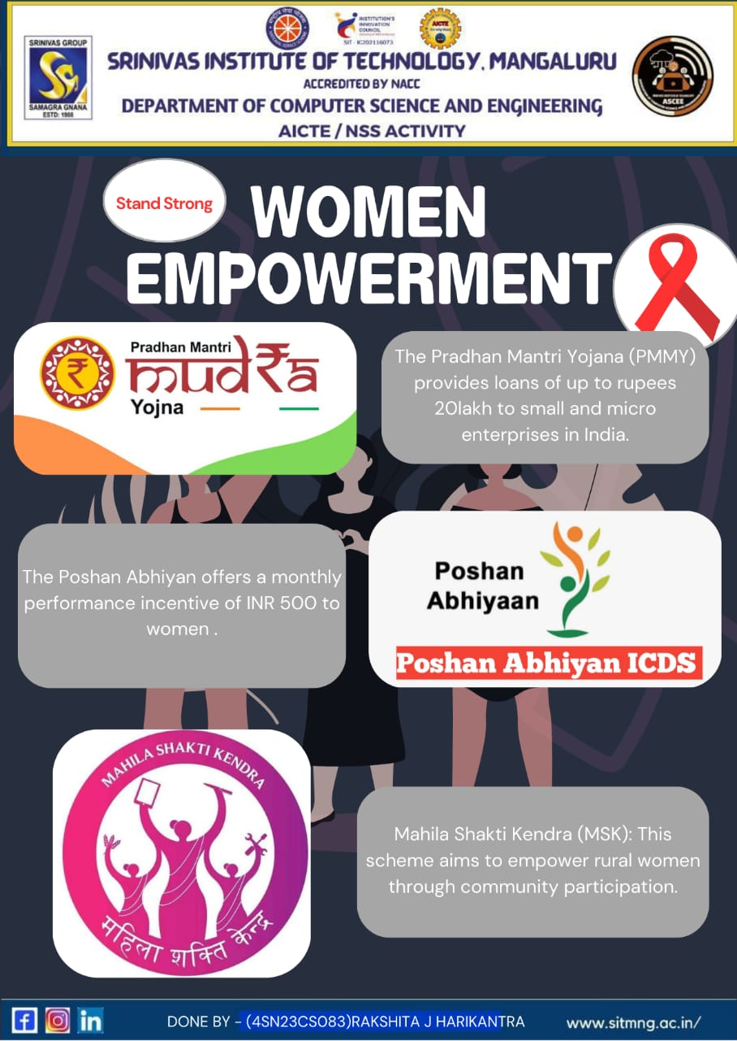**POSTER**

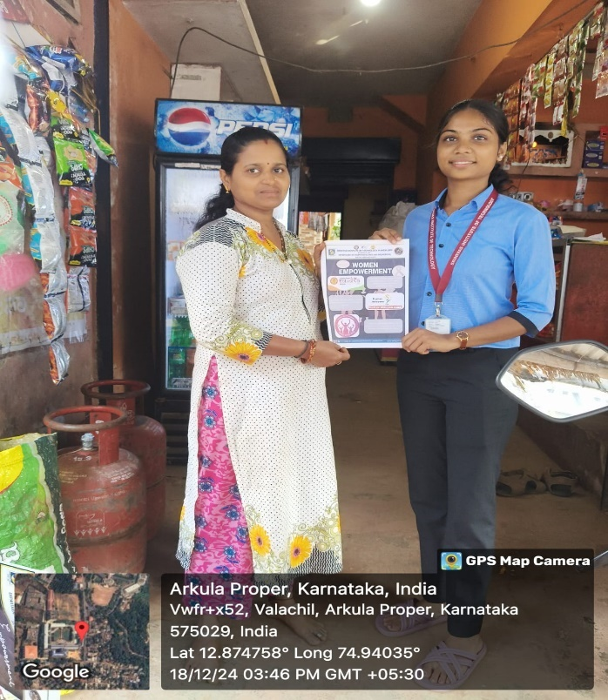 **Geo Tagged Photos**

|  |  |
| --- | --- |
|  |  |
|  | |
|  |  |
|  | |

|  |  |
| --- | --- |
|  |  |